Lakeview Elementary – Revised Jan 7, 2022
COVID-19 Communicable Disease Health and Safety Plan
*This document builds upon the
Provincial COVID-19 Health & Safety Guidelines for K-12 Settings

Personal Measures
Daily Health Checks
Staff, parents and students will be regularly reminded of their responsibilities to complete a Daily Health Check and are provided with resources on how to complete one (e.g., the K-12 Health Check app).
The daily sign in will confirm the staff/visitors completion of the Health Check. (District staff will sign in at main entrance to confirm health check has been completed. “When to get tested for COVID-19” poster will be posted at sign in.). Other visitors will sign in with the secretary.
- Staff will be reminded weekly of responsibility to complete the Health Check daily. – Have reminder on the whiteboard in the staffroom and send weekly memo.

Stay Home When Sick / What To Do When Sick
Students, staff or other adults must stay home if they are required to self-isolate. Additional information on self-isolation requirements and support is available from BCCDC.
Students, staff or other adults should stay at home when sick, as this is one of the most important ways to reduce the introduction to and the spread of COVID-19 in schools. The following resources provide guidance regarding specific symptoms of illness:
- Parents/caregivers and students can use the K-12 Health Check app
- Staff and other adults can refer the updated Daily Health Check
- Staff, students and parents/caregivers can also use the BCCDC online Self-Assessment Tool, call 8-1-1 or their health care provider.

Symptoms Develop at School
Some students or staff may not be able to be picked up immediately. Schools will have a space available where the student or staff can wait comfortably and is separated from others (at least 2M), and provide the student or staff with a mask if they do not have one. – Students will wait in the medical room. Masks will be available in the office and the medical room.
Schools must provide supervision for younger children. Supervising staff should wear a non-medical mask and face shield if they are unable to maintain physical distance, avoid touching bodily fluids as much as possible, and practice diligent hand hygiene. –Staff supervising indoors will wear a mask even if physical distance is provided.
Staff responsible for facility cleaning should clean and disinfect the surfaces/equipment, which the person’s bodily fluids may have been in contact with while they were ill.- Staff who makes final contact with the student before they leave will disinfect the areas of concern. If they are unable to, they will let the office staff/admin know. Once the room has been disinfected a green sign will be posted. If it has not been disinfected, then a red sign will be posted on the door of the room.

Returning to School After Illness
When a staff member, student or other adult can return to school depends on the type of symptoms they experienced (as indicated in the K-12 Health Check app and BCCDC When to get tested for COVID-19 resource, if a COVID-19 test is recommended, and the type of illness they had (e.g. COVID-19 or other illness). See Appendix A COVID-19 Symptoms, Testing & Return to School for more information regarding what to do when experiencing COVID- 19 symptoms.
Students and staff who experience symptoms consistent with a previously diagnosed health condition (e.g. seasonal allergies) can continue to attend school when they are experiencing these symptoms as normal. They do not require re-assessment by a health-care provider and should not be required to provide a health-care provider note. If they experience any new or unexplained symptoms, they should seek assessment by a health-care provider. –School will contact parents if unsure about an allergy or symptom (allergy…).
Students or staff may still attend school if a member of their household develops new symptoms of illness, provided the student/staff has no symptoms themselves. If the household member tests positive for COVID-19, public health will advise the asymptomatic student/staff on self-isolation and when they may return to school.

Hand Hygiene & Respiratory Etiquette
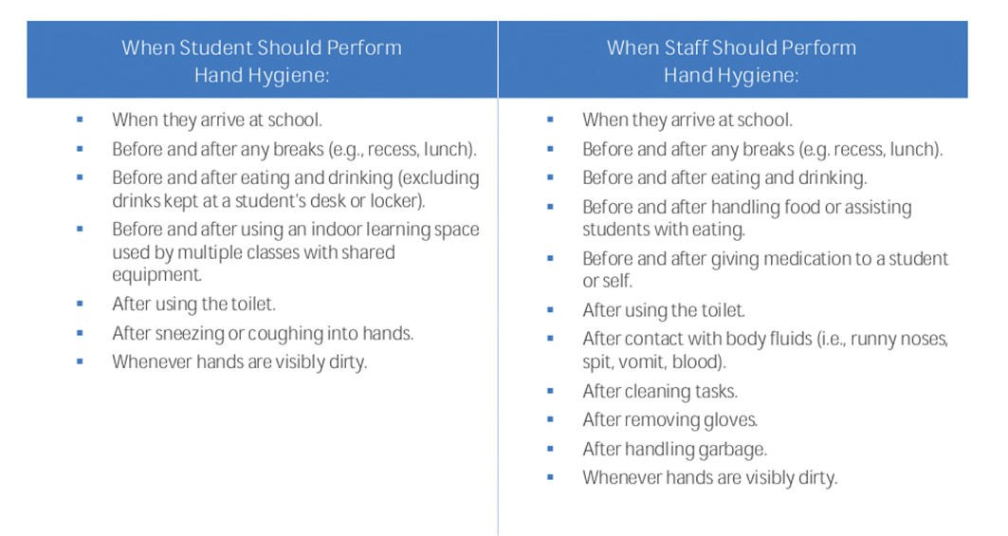
Hand cleaning facilities are available and accessible throughout the school and are well maintained. Diligent hand hygiene will be promoted to staff and students regularly.

Personal Protective Equipment

Masks

All K-12 staff are required to wear a mask indoors in schools and on school buses. Staff may wear a face shield in addition, but must wear a mask under the face shield.
Masks are available for those who have forgotten theirs. – Disposable masks are available in the office. Students will be encouraged to use only 1 in a given day and be reminded to bring their own reusable mask.

Exceptions to the mask requirements for staff, students and visitor can be found in the Provincial COVID-19 Communicable Disease Guidelines for K-12 Settings – Updated October 1, 2021 on page 19.

No changes but district/sites/classroom mask reminder to go out stressing importance

Supportive School Environments

Personal Space
Strategies are in place to encourage staff and students to consider and respect others personal space. Personal space is the distance from which a person feels comfortable being next to another person. Physical distancing of 2M is no longer a requirement. –Teachers will do culturally sensitive direct teaching about personal space as needed.

Public Health Measures

Attendance & Record Keeping
Staff and visitor sign in and confirmation of completion of the daily health check is required at all sites. A list of the date, names and contact information for all visitors and staff who entered the school will be kept for 45 days. – Non District Staff will sign in at the office with the secretary and provide name and contact information. District staff will continue to use self-serve sign-in at the main entrance.
Accurate class and bus lists will be maintained and kept for at least 45 days.

Environmental Measures

Ventilation and Air Exchange
All HVAC systems are operated and maintained as per standards and specifications, and are working properly. Filters have been upgraded and will be regularly monitored and replaced.
Use of portable air conditioners and fans in unventilated spaces with doors and windows closed should be avoided. Risk mitigation strategies are identified for excessive heat events or times of poor air quality.

Administrative Measures
Communicable Disease Checklist
All sites to complete and send to Tracy Ruether at TracyRuether@sd28.bc.ca .

Cleaning and Disinfecting
Cleaning practices will include:
- Frequently touched surfaces (those touched by larger numbers of people) are cleaned and disinfected at least 1x/day.
- Surfaces touched by fewer people are cleaned 1x/day.
- Practices will be in place to clean and disinfect frequently touched surfaces when they are dirty. – Classes and rooms will be provided with bottles of disinfectant and a cloth to clean as needed.
- Other general cleaning occurs in line with regular practices.
- Practices are in place to clean and disinfect any surfaces a person’s body fluids have contacted after they have displayed symptoms of illness. Staff who notice the areas of concern will disinfect using the spray bottle and cloth and let the office staff/admin know.

Gatherings and Events
School extracurricular and social gatherings and events (including those occurring within and between schools) are in line with those permitted as per relevant local, regional, provincial and Federal health recommendations and Orders.

Hold school gatherings and events (e.g., assemblies, parent-teacher interviews, etc.) virtually.*
If gatherings and events must be in- person (e.g., inter-school sports game, theatre productions), minimize the number of people in attendance as much as possible, do not exceed 50% operating capacity, and do not allow spectators.

Space Arrangement
During breaks and other unstructured time in indoor settings, strategies will be in place to maximize space between people to prevent involuntary physical contact.– Lunch and recess will be staggered with a 5 minute transition time between groups.
Reduce crowding:
Maximize space between people
- Different common space, classroom, and learning environment configurations (e.g., different desk and table formations) • Limit, and whenever possible, avoid face-to-face seating arrangements. - In classrooms, seating will be arranged shoulder to shoulder and distanced to avoid face to face interactions whenever possible.
Implement strategies that prevent crowding during class transition and break times
- Stagger start/stop times, or recess/snack, lunch and class transition times
- Regular learning activities that bring together multiple classes (e.g., exams, physical education) should be spread out across multiple locations/spaces whenever possible but do not need to be reduced in size.

- Intermediate classes who use the main entrance will have more of a staggered entry/exit.
- Division 6 (Salmons/Loureiro) will use their classroom door as their exit at recess, lunch and after school.
Limit student bathroom capacity to 4 people. Waiting spaces will be marked with a circle in the hallway.
Learning activities:
For activities involving multiple classes (eg. Buddy reading), students will be spread out in multiple classes and hall rather than all being in the same class.

Staff Spaces Only
  - schools and other worksites will implement the following strategies:
    - Utilize floor markings and signage to direct traffic flow and prevent crowding (e.g. in the break room, by the photocopier, etc.).
Hold staff-only gatherings virtually (e.g., staff meetings, in-service and professional development activities) *
Room capacities:
    - Staff room limit will be 2 per table if eating and 1 person entering briefly (not seated) to get lunch etc. Alternative eating space will be provided from 12:00-1:30 in room 5 for those who want more space. Microwave to be added to room 5 for lunch.
    - Copy room: 2 people working plus 1 (short stay).
    - Kitchen: take measures to provide space between people (eg: assigned work area).
    - Meetings and staff-only gatherings will be held virtually.

Visitors Access/Community Use
Sites should go back to locking entrance doors*; however, parents and visitors must make appointments to enter the school.
Visitor access to schools may be restricted by local or provincial public health orders or recommendations from a medical health officer. See the Regional Differences section for more information.
Schools are responsible for ensuring that visitors are aware of communicable disease protocols and requirements, and have completed a daily health check, prior to entering the school. Office staff will confirm with visitors when they sign in that they are symptom free and have done the health check.

Information on communicable disease protocols and requirements for visitors should be posted by the entrance to the school and included in communications to students and families.
All visitors must wear a non-medical mask when they are inside the school. See the Personal Protective Equipment (PPE) section for more information, including exceptions to mask requirements for visitors.
Where possible, visitor access should be limited to those areas required for the purpose of the visit (e.g. school office for drop-off/pick-up of items, gymnasium for a sports event, etc.). Parents dropping off supplies (lunch, backpack) for their students will call or knock on the main entrance. The secretary or principal with collect the items at the door.

Parents/caregivers are encouraged to drop-off/pick-up students outside of the school.
Parents/caregivers and other visitors should respect others personal space while on school grounds including outside.
Limit visitors to those that are supporting activities that are of direct benefit to student learning and wellbeing Guest speakers should be virtual – Signage will be posted to inform parents to phone the office to make an appointment.

Sports:
Extracurricular sports tournaments should be paused.
Sports tournaments are a single or multi-day gathering of three or more sports teams, who come together outside regular league play for the purpose of teams playing against multiple other teams, but does not include:
- A gathering where team members compete on an individual basis against members of other teams, or
- A gathering where the result will decide if a team will advance to play in a national or international competition.

Curriculum, Programs and Activities
For music and physical education (and other subjects as necessary), prevention practices specific to the activity can be found in the Provincial COVID- 19 Communicable Disease Guidelines for K-12 Settings – Updated August 24, 2021 on page 26.

Local day field trips are approved at this time. No overnight travel.
Local and international field trips will occur in line with those permitted as per relevant local, regional, provincial, and Federal public health recommendations and Orders for local and/or international travel.
Any new field trips for consideration to be sent to Tracy Ruether at TracyRuether@sd28.bc.ca for Senior Team to review.
Local and international field trips will occur in line with those permitted as per relevant local, regional, provincial, and Federal public health recommendations and Orders for local and/or international travel.

Student Transportation
Bus cleaning practices will include:
- Frequently touched surfaces on school buses will be cleaned and disinfected at least 1x/day.
- Surfaces touched by fewer people are cleaned 1x/day.
- Practices are in place to clean and disinfect frequently touched surfaces when they are dirty.
- Other general cleaning occurs in line with regular practices.
- Practices are in place to encourage bus drivers and passengers to practice hand hygiene before and after trips.
Bus passengers will be spread out if empty seats are available.

Bus windows are opened when the weather allows.

Bus drivers, adult volunteers and visitors, and students in Grade 4 or higher wear masks according to the guidelines or applicable public health orders/recommendations.
Grade K-3 students wear masks based on their personal or family/caregivers’ choice.
Carpooling - for carpooling related to school activities, students, staff and other adults must follow the mask requirements. Spread out vehicle occupants as much as possible. Travel with the same people whenever possible. Hand hygiene before and after trips.

–School will inform drivers of the above requirements and make sure volunteers have done the health check.

Food Services
Food services (e.g., meal programs, cafeterias, fundraisers, etc.), are following regular operational and food safety practices. Schools should continue to emphasize that food and beverages should not be shared. – Food that can be served with tongs (store bought pizza, store bought cupcakes…) or that is individually packaged is OK to handout by an adult who has followed hand hygiene protocols.

Community Use of Schools
Community use of school facilities is aligned with related public health guidance, recommendations and Orders. Safety plans are required from user groups.

Water Fountains
The use of water fountains is not limited. Fountains will be cleaned/disinfected daily. – Teachers and staff will do direct instruction about not making contact while drinking from the fountain.

________________________________________________________________________________________________________________________
September 2021 wording below; *replaced with new wording
At this time, indoor gatherings are limited to 50 people or 50% capacity of the space.
Utilize floor markings and signage to direct traffic flow and prevent crowding (e.g. in the break room, by the photocopier, etc.).
For gatherings (e.g. meetings, pro-d, etc.), respect room occupancy limits, use available space to spread people out, and consider virtual options. Gatherings must also occur in line with those permitted as per relevant local, regional, provincial and federal public health recommendations and Orders and any related WorkSafe BC guidance.
Schools will leave front doors unlocked for visitor access.

